# **Introduction to DDBMS**

**Homogeneous distributed data-base**If the data is distributed across different sites, but all the servers run the same DBMS software.  
Must easier to design and manage.  
It appears to users as a single system.  
Advantage 🡪 Easy to use manage and design.  
Disadvantage 🡪 Difficult for most organizations to force a homogeneous environment.  
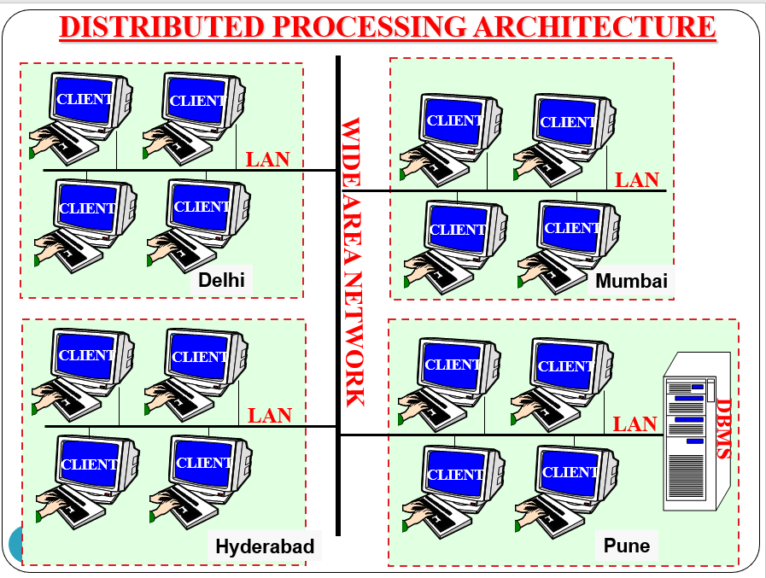

**Heterogeneous distributed data-base**In this type, different data centers may run different DBMS products, with possibly different underlying data-model.  
Occurs when sites have implemented their own data-bases and the integration is considered later.  
**Advantage**Huge data can be stored in 1 global center from different databases center.  
Remote access is done using global schema.  
Different DBMS may be used at each node.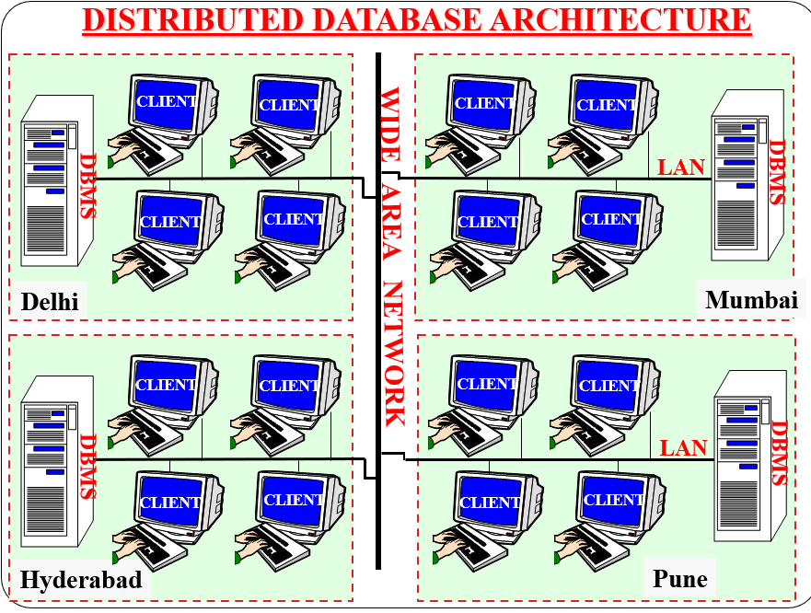

Transparent 🡪   
Location Independence 🡪

# **Architecture of DDBMS**

## **Client-Server architecture**

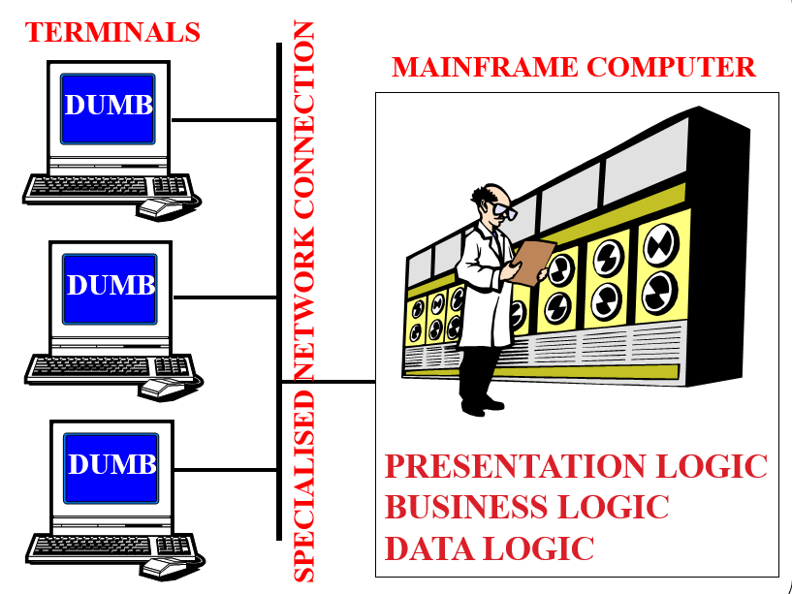

A Client-Server system has one or more client processes and one or more server processes.  
A client process can send a query to any one server process.   
Clients are responsible for user-interface issues.   
A client process could run on a personal computer and send queries to a server running on a mainframe.  
Servers manage data and execute transactions.   
  
**The Client-Server architecture does not allow a single query to span multiple servers**

## **Collaborating-Server architecture**

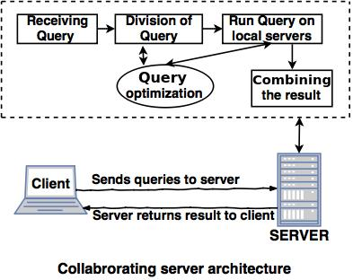

* Collaborating server architecture is designed to run a single query on multiple servers.
* Servers break single query into multiple small queries and the result is sent to the client.
* Collaborating server architecture has a collection of database servers. Each server is capable for executing the current transactions across the databases.

## **Middle-ware architecture**

# **Storing the data in DDBMS**

## **Fragmentation**

* Fragmentation 🡪 The process of dividing into smaller multiple parts.
* All these fragments are stored at different location.
* The data fragmentation process must be carried out in such a way that the reconstruction of original data from the fragments must be possible.

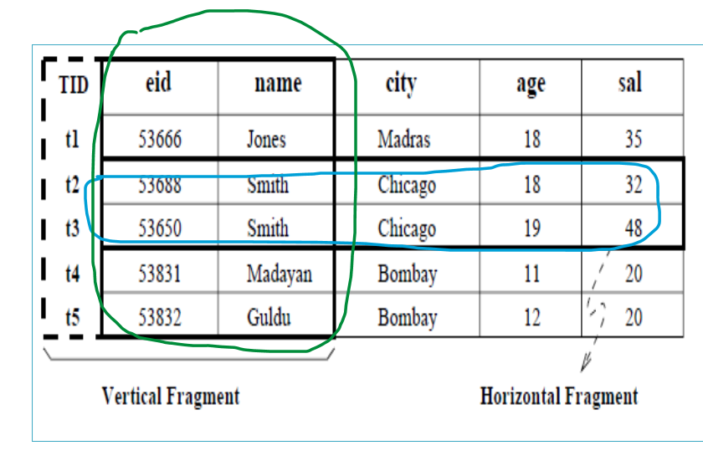

## **Types of Fragmentation**

* **Horizontal fragmentation**
* Dividing a relation(table) horizontally into the group of rows to create subsets of tables.
* The union of the horizontal fragments must be equal to the original relation. Fragments are usually also required to be disjoint.
* Eg: Account ( Account_no , balance , branch_name )  
  Select * from Account where branch_name = “Chennai”

**Primary Horizontal fragmentation  
Derived Horizontal fragmentation**  
**Complete Horizontal fragmentation  
Disjoint Horizontal fragmentation**  
**Reconstruction of Horizontal fragmentation**

* **Vertical fragmentation**
* The collection of vertical fragments should be a lossless-join decomposition.
* Dividing a relation vertically into groups of columns to create subsets of table.s

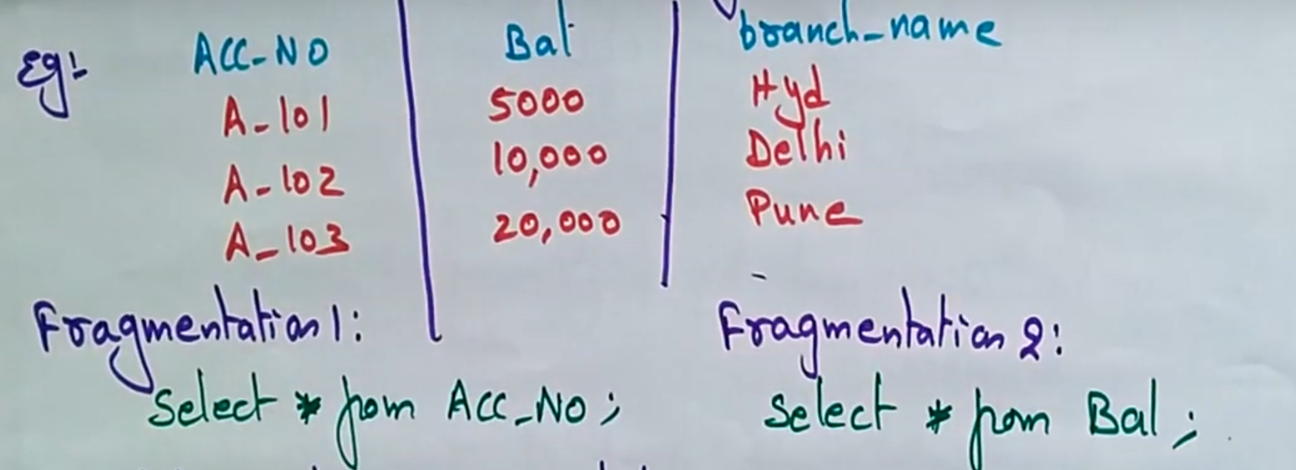

**Complete Vertical fragmentation**It generates a set o vertical fragments which can include all the attributes of the original relation.  
Reconstruction of the vertical fragmentation is done by using Full outer join operation on fragments**.**

**Hybrid fragmentation**

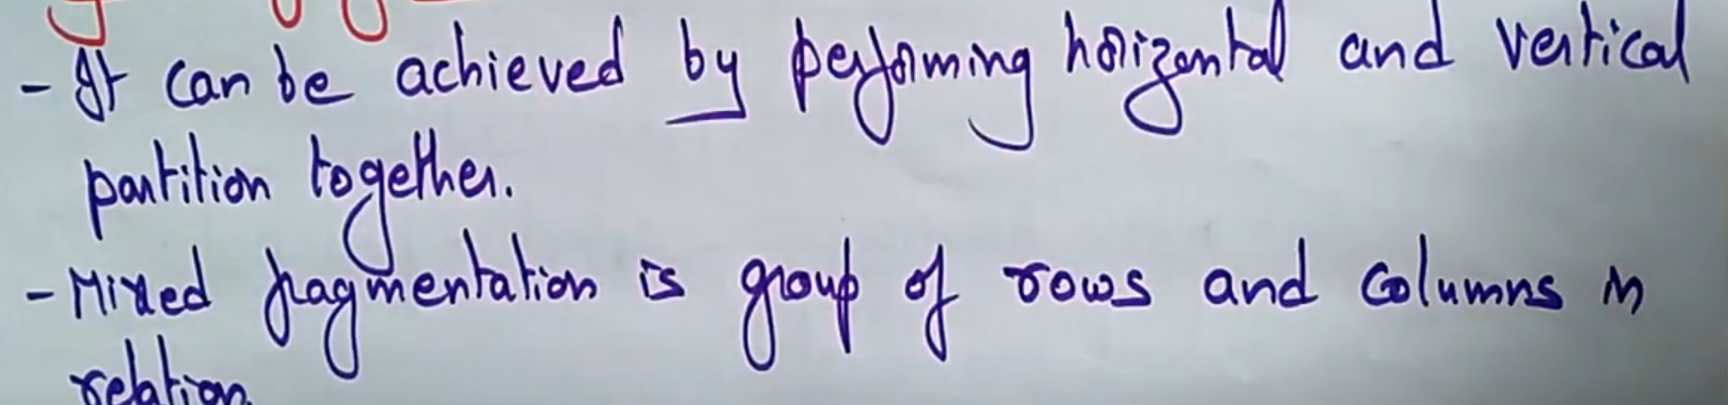

**Data Replication in Distributed Data-Base Systems**

Process by which data is copied at multiple locations (different computers/servers) to improve the availability of data.

**Complete Vertical fragmentation**